**Classroom Activity: Installation of Node JS**

**Step 1:**

**Download the Installer:**

* Go to the [Node.js official website](https://nodejs.org/).
* Click on Download.
* Download the Windows **prebuilt installer** (.msi) for the latest LTS (Long Term Support) version.

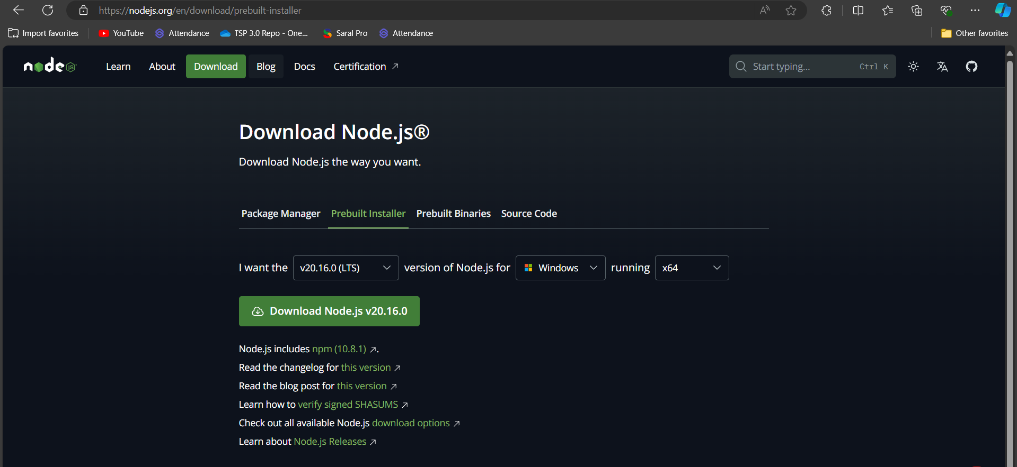

Figure: Download of Nodejs

**Step 2:**

**Run the Installer:**

Now you need to install the node.js installer on your PC. You need to follow the following steps for the Node.js to be installed:-

* Double-click on the .msi installer.
* *The Node.js Setup wizard will open.*
* Welcome To Node.js Setup Wizard.
* *Select “Next”*

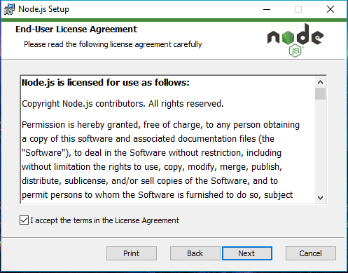

Figure: Nodejs license Agreement

* Destination Folder
* *Set the Destination Folder where you want to install Node.js & Select “Next”*

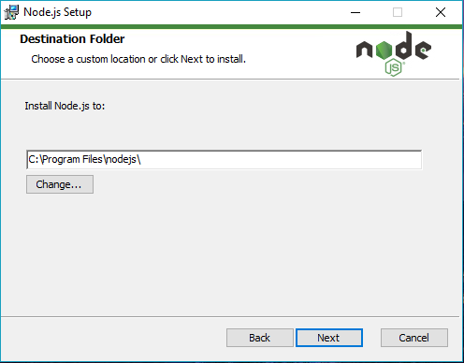

Figure: Choose destination Folder

* Ready to Install Node.js.
* The installer may prompt you to “install tools for native modules”.
* ***Select “Install”***

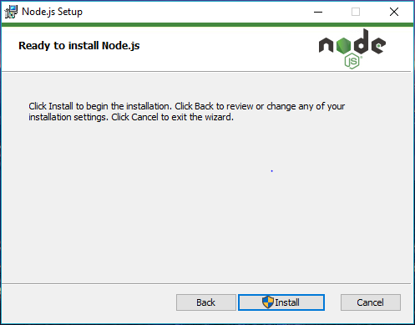

Figure: Ready to install Nodejs

* Installing Node.js.
* Do not close or cancel the installer until the install is complete
* Complete the Node.js Setup Wizard.
* *Click “Finish”*

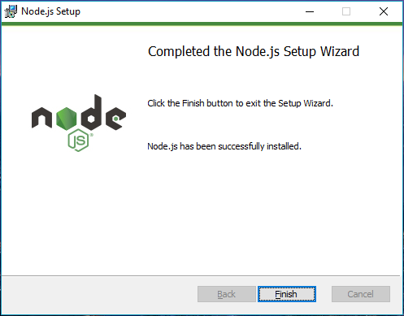

Figure: Nodejs Setup

**Step 3:**

**Verify Installation:**

* Open Command Prompt.
* Run the command: node -v to check the Node.js version.
* Run the command: npm -v to check the npm version.

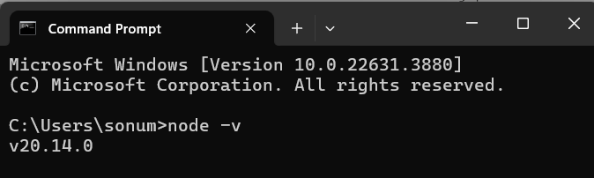

Figure: Check Nodejs Version

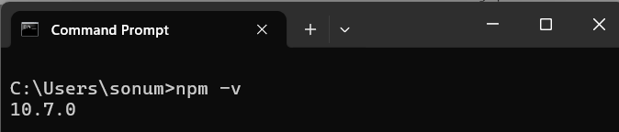

Figure: Check npm version